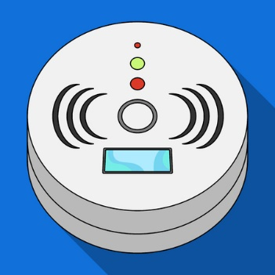 **MEMO**

DATE: June 27, 2024

TO: Unit Owners & Residents of Snowline Inn Condominium   
Association

FROM: Cindyrae Mehler & Tess Allison

Condominium Association Property Managers

RE: MANDATORY 5-Year Smoke Detector Sensitivity Testing

**_______________________________________________________________________________________**

**THIS MEMO shall serve as advance notice that the 5-year smoke detector sensitivity test will take place on Friday, July 26, 2024, between the hours of 9:00 am and 5:00 pm. The testing will be performed by a Security Solutions technician and a member of INTEGRA’s staff will be onsite for the individual unit testing.**

During these inspections, we will need access to every unit. You are welcome to be present during the inspections, but it is not required.

***Please contact INTEGRA to verify we have a key on file for your unit, or if you plan on being present during the inspection. Be advised, if entry access to your unit is not available on the date of inspection – the unit owner is responsible for any   
re-inspection fees.***

***INTEGRA and Security Solutions are not responsible for any pets in the units. This is not a pleasant experience for animals, so, if possible, please either be present with your pets, or remove them from the unit on the day of the scheduled inspection for your Building.***

If you have any questions, please call our office at **360-656-5091** or email us at [integra@integra2183.com](mailto:integra@integra2183.com). Our office hours are M-F, 9am to 4pm.

**THANK YOU!**